**YEAR 12 PHYSICS**

**TEST 1, 2021**

**TASK 2**

**VECTORS, PROJECTILE AND CIRCULAR MOTION**

**STUDENT NAME: SOLUTIONS**

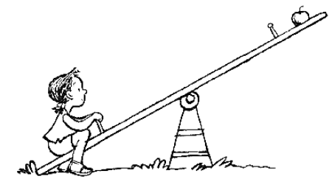

* **Answer all questions.**
* **Show all working.**
* **When calculating numerical answers, show your working or reasoning clearly.**
* **Give final answers to three significant figures and include appropriate units.**
* **When estimating numerical answers, show your working or reasoning clearly. Give final answers to a maximum of two significant figures and include appropriate units.**

1. (4 marks)

A free body diagram shows all the directions and labels of forces acting on a body. Draw the free body showing **ALL** forces for a block sliding along a floor with friction, sometime after it has been kicked and while it is still moving. Show on your diagram the direction of motion of the block.

Normal reaction

Direction of motion

Friction

Weight

2. (4 marks)

During the Red Bull Air Race in Perth, a 92.0 kg pilot executed a loop-the-loop of radius 375 m at an air speed of 225 km h-1. What was the force between the pilot and his seat at the top of the loop?

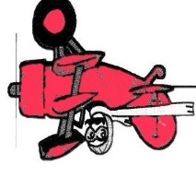

225 km h-1 = 62.5 m s-1 (1 mark)

+

FC = Fg + Freaction

Freaction = - FC - (- Fg) (1 mark)

-

= - $\frac{{mv}^{2}}{r}+mg= -$ ( $\frac{{92 x 62.5}^{2}}{375}$) +(92.0 x 9.8) = - 56.7 N or 56.7 N down

1+1 mark for direction

.

3. (1 mark)

A ball is thrown from S at an angle to the horizontal as shown in the diagram below.

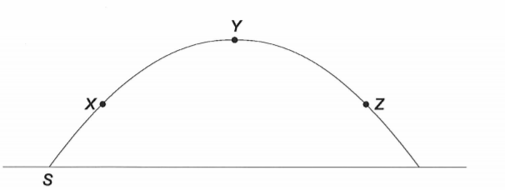

X, Y and Z are different positions along the ball’s trajectory.

Which of the following, (A), (B), (C) or (D), best represents the velocity and acceleration of the ball at positions X, Y and Z? Write your answer in the space below the table.

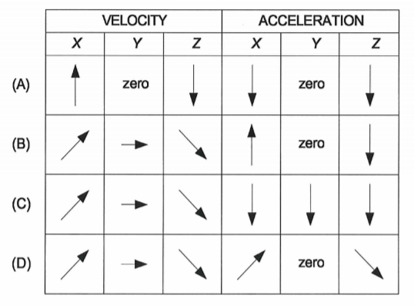

ANSWER: **C**

4. (4 marks)

A projectile follows a parabolic arc from point A to point B as sketched in the diagram below. The displacement of the projectile is measured from the launch point.

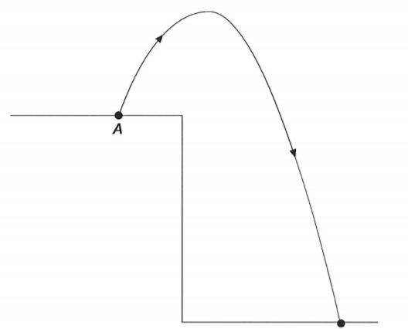

**B**

If air resistance is neglected, answer the following by writing True or False.

1. The total time of flight is twice the time to reach maximum height.

True or False? **False**

1. The velocity has maximum magnitude when the displacement is zero.

True or False? **False**

1. The vertical component of the acceleration depends on the direction of the initial velocity.

True or False? **False**

1. The range depends on the initial velocity. True or False? **True**

5. (4 marks)

A boat, which has a speed of 5.00 km h-1 in still water, crosses a river of width 1.00 km along the shortest possible path in 15.0 minutes. What is the speed of the river current? Include a labelled diagram in your working.

**S stands for shore**

VWS

1 mark for diagram

vBS

VBW = = 5.00km h-1

= 1.39 m s-1

s = 1.00 km/ 1000 m, 15 minutes = 0.25 h/ 900 s (1 mark)

vBS = = = 4.00 km h-1 (1 mark)

River current = VWS =) =3.00 km h-1 / 0.833m s-1 (1 mark)

6. (6 marks)

a. A 54.3 kg block is placed on an inclined plane that is 42.4o from the horizontal. What is the acceleration of the block as it slides down the plane? Ignore friction.

(3 marks)

Fg = m g = 54.3 x 9.8 = 532.14 N (1 mark)

$Fx = FgsinƟ= 532.14\sin{42.4=}358.8 N$ (1 mark)

a = = 6.61 m s-2 (1 mark)

b. If the block slides down a distance of 5.20 m along the inclined plane, how long does it take the block to reach the end of the plane? (3 marks)

u = 0 m s-1 (1 mark)

s = 5.2 m

s = ut + $\frac{1}{2}$ a $t^{2}$ (1 mark)

t = = = 1.25 s (1 mark)

7. (4 marks)

A golf ball is hit with an initial vertical velocity of 23.0 m s-1 and a horizontal velocity of 33.0 m s-1. Ignore air resistance. If it falls back at the same level that it was hit from, calculate

a. how high does it go? (2 marks)

uv = 23.0 m s-1

vv = 0 (1 mark)

vv2 = uv2 +2gsv

0 = 232 –(2 x 9.8 x sv)

sv = = 27.0 m (1 mark)

b. how long is it in the air? (2 marks)

sv = uv t + g t2

0 = 23 t - 4.9 t2 (1 mark)

- 23t = - 4.9 t2

t = = 4.69 s (1 mark)

8. (7 marks)

A helicopter is rising vertically at a uniform velocity of 14.7 m s-1. When it is 196 m from the ground, a ball is projected from it with a horizontal velocity of 8.50 m s-1 with respect to the helicopter. Ignoring air resistance, calculate

a. the time the ball takes to reach the ground? (2 marks)

uv = 14.7 m s-1

uh = 8.5 m s-1

sv = uv t + g t2

-196 = 14.7 t - 4.9 t2 (1 mark)

t = 8.0 s (1 mark)

b. its velocity when it hits the ground? (5 marks)

v = ( vv2 + vh2) No penalty again if uv = 0

vv = uv + g t = 14.7 – (9.8 x 8) = - 63.7 m s-1 (2 marks)

v = (-63.7)2 + 8.52 = 64.3 m s-1 (1 mark)

Ɵ = tan-1 () = 82.4o below the horizontal (1 + 1)

9. (8 marks)

During a game of totem tennis a ball of mass 60.0 g swings freely in a horizontal circular path. The string is 1.30 m long and is at an angle of 39o to the vertical as shown in the diagram.

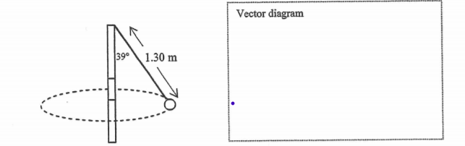

1. Draw a vector diagram showing the forces acting on the ball and the sum of those forces in the space indicated above. (3 marks)

**1 mark only if a free body**

**diagram is drawn or arrows not shown/ wrongly drawn/ missing labels**

Weight Tension

Fnet

1. Calculate the net force acting on the ball. (2 marks)

tan 39o = (1 mark)

Fnet =mg tan 39o = 60 x 10-3 x 9.8 tan 39o

= 0.476 N (1 mark)

1. Calculate the time the ball takes to complete one revolution. (3 marks)

tan 39o =/(mg) = (1 mark) **Various ways to answer this question**

v2 = r g tan 39o

v = 1.30 sin 39 o x 9.8 x tan 39o)

= 2.548 m s-1 (1 mark)

T = = = 2.02 s (1 mark)

10. (3 marks)

A projectile’s range sh and vertical displacement, sv are connected by time. If it is projected at an angle $θ$, with velocity, u derive the following relationship –

sv = sh tan $θ$ + $\frac{1}{2}$ g $\frac{s_{h}^{2}}{{(u\cos{Ɵ})}^{2}}$

**Derivation**

sv = uvt + g t2

sh = uh t

= u cos $θ t$ (1 mark)

t = $\frac{s_{h}}{u\cos{θ}}$

sv = u sin $θ x$ $\frac{s_{h}}{u\cos{θ}}$ + $\frac{1}{2}$ g $\frac{s_{h}^{2}}{{(u\cos{Ɵ})}^{2}}$ (1 mark)

sv = + g $\frac{s_{h}^{2}}{{(u\cos{Ɵ})}^{2}}$ (1 mark)